Davisbase Database engine:

Screenshots of various commands

Initial screen:

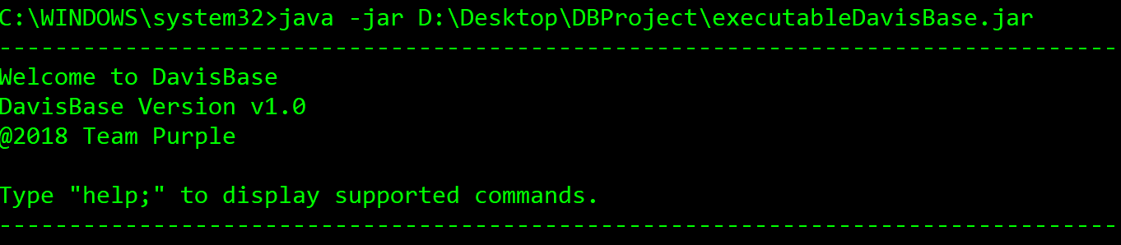

Help command:

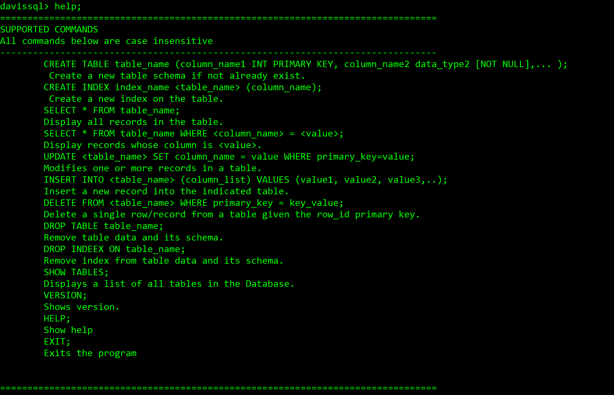

Create table:



Show tables:

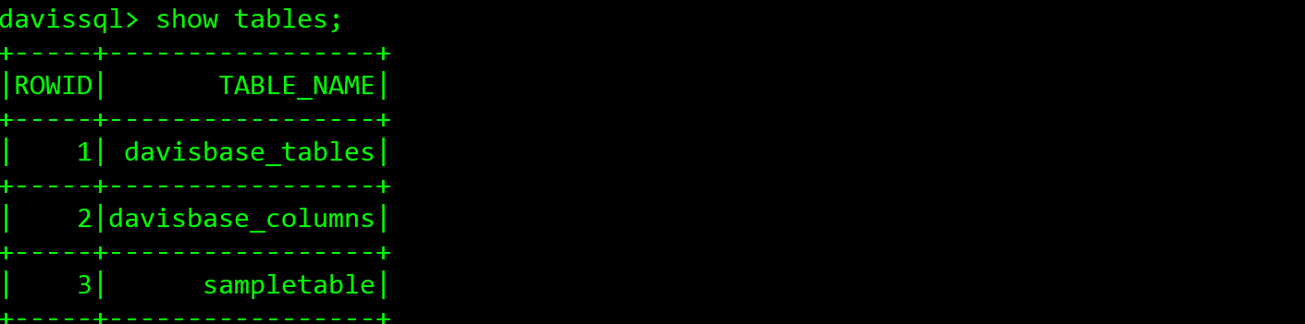

Insert records:

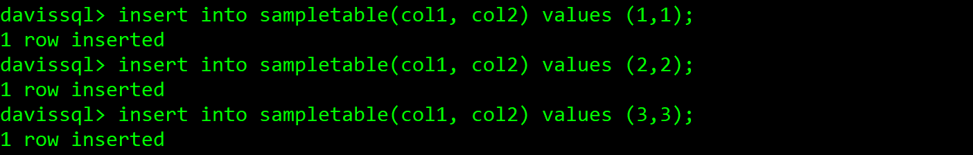

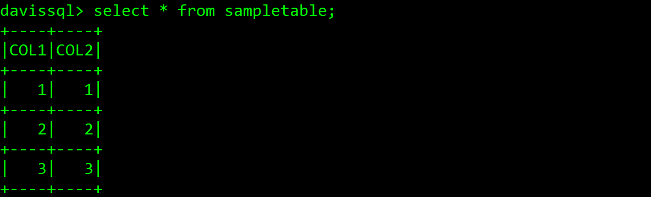

Update records:

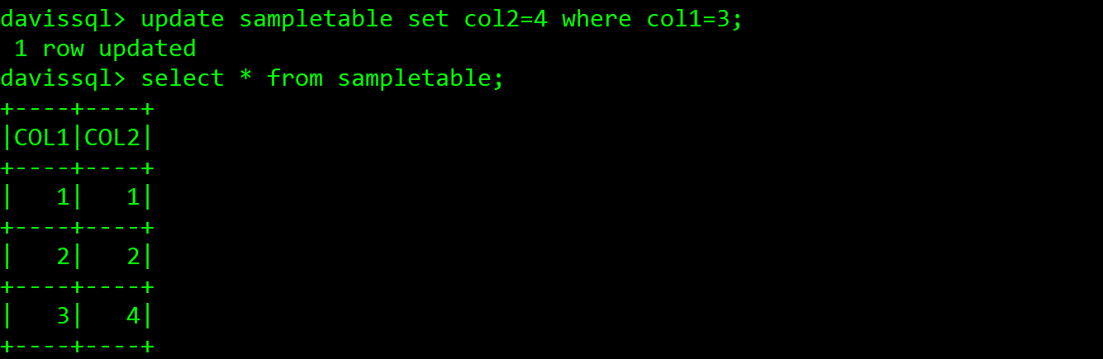

Delete records:

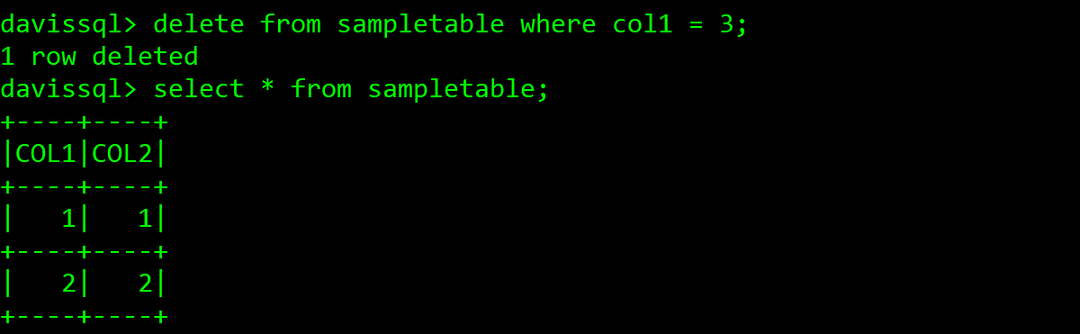

Drop table:

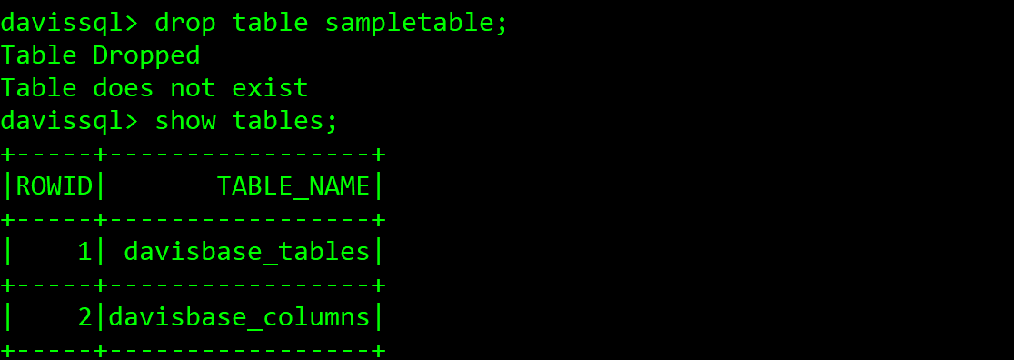

Index:

